Since the countries open to free trades, the commodities liquidity becomes more frequent. The bilateral trade between China and US make a significant contribution to the GDP of China. US, which is an obvious country of trade surplus, recently place a tariff to China. This article illustrates the effect of the Chinese economy when China places retaliatory tariffs on US import from the short run and long run respectively.

The GDP for China experienced massive growth during the past 20 years, along with the volume of the trade with the US. Xie (2014) states that 1% increase of Chinese export will make Chinese GDP grow 0.455% and 1% growth of Chinese imports from the US will lead to 0.825% increase of China’s GDP. It is precisely seen that China imports from the US increased from 63 billion to 104 billion approximately from 2007 to 2014 and the GDP of China increased by 8 trillion. However, the growth of GDP is increasing with a decreasing rate. As we can see from the figure 1, the growth rate from 2014 to 2015 is equal to (11T-10T)/10T=10%T, while from 2015 to 2016 growth rate is equal to (11.3T-11T)/11T=2.7%T.

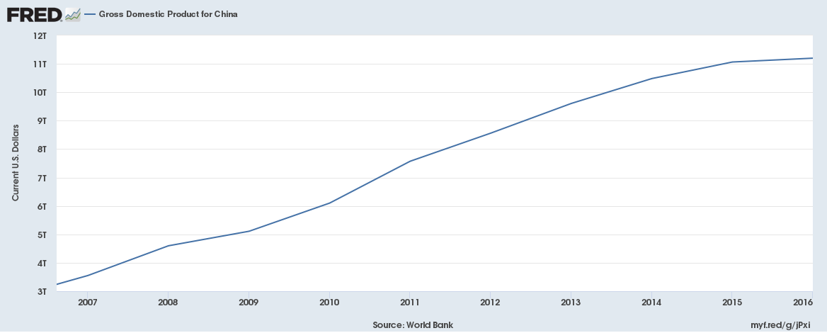

Figure 1. Gross Domestic Product for China, FRED, Federal Reserve Bank of St. Louis, 2018

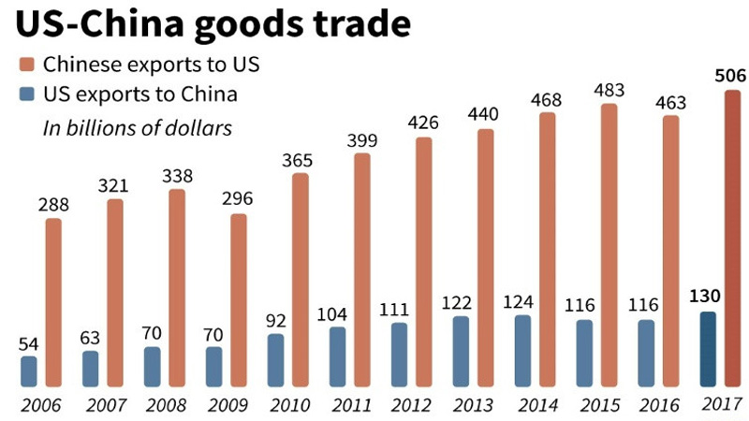

Figure 2. US-China Goods Trade, The independent, 2018

Once China places the tariff on US imports aimed to protect domestic producer from cheaper imported goods, the Chinese economy will fluctuate to some extent. In the short run, the increasing trade barriers makes the US import goods lose its price advantage, and pushes consumers focus more on the domestic products. Rosyadi & Widodo (2018) states that the decrease of an import demands of goods is due to an import tariff. Also, the US will decrease some of its exports for the maximum profit. It means China will has a more net export. Based on the theory ‘GDP= Consumption + Investment + Government Purchase + Export –Imports’, the increase of consumption and net export will lead to the growth of the GDP.

The Office of the United States trade representative (2016) shows that the majority categories that US export to China are cereals, including grains, seeds and fruits, which contains $15 billion, aircraft, represents $15 million and electrical machinery ($12 million). Rosyadi & Widodo (2018) mentioned that the demanded of the quantity of goods would be changed because of the relative price and the substitute’s elasticity after placing the tariff on the imports. The cereals, which are the substitutes, has less impact on the demand for the goods to the consumers. When the price of the cereals increases because of the tariff, consumers will choose to buy the similar thing produced by China. It will cause the increase of consumptions; thus the GDP will grow. However, the aircraft and electrical machinery are necessities. The US has fully comparative advantage in the production and innovation about this area. Compared with the US, China is lack of the high technology, and it is hard to change the phenomena in a short time, even if the price of these high-tech increase, China will not decrease the demand in the short run. This means the GDP will increase because the growth of the investment, the huge amount of investment and the government purchase.

In the long run, the tariff, causing the world price increase (Pw to Pw+e), will lead to a lower quantity demanded, from Qd to Qd’. This phenomenon indicates the consumer surplus and supplier surplus will decrease, and the area J and area G are the deadweight loss. This means consumers cannot buy the products with higher quality and new category as before; the social welfare will get a loss. Pettinger (2017) states that the government revenue will increase after the tariff, and the tax in the economy will not decrease significantly. Meanwhile, if the basket is fixed, consumers spend more money in the products will probably lead to the growth of the CPI. Also, the tariff makes the suppliers have the obligation to supply more products to satisfy the surplus demand. It means more labor force will be needed to provide for the demanded quantity. Thus, the unemployment rate in China will be improved, the structural unemployment specially. Tariff will make the domestic industry more competitive and more jobs are visible (Pettinger, 2017).

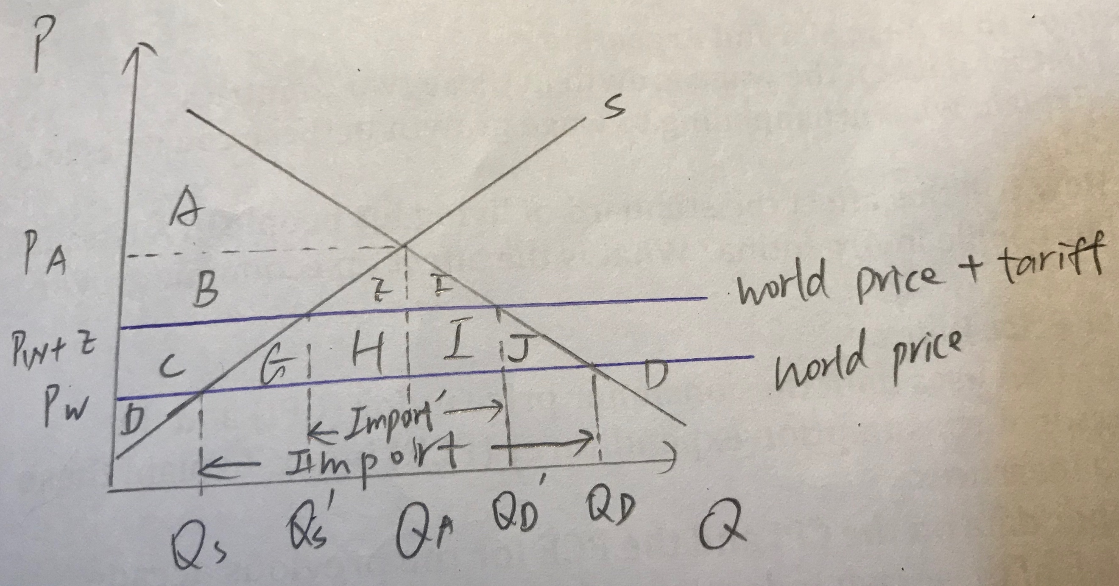

Figure 2. The Domestic Price and Quantity Demanded

In conclusion, the countries are becoming more of connection today. Even if the impact of the Chinese economy after the tariff on the US imports in the short time seems growing because of the domestic consumption, in the long run, it will still decrease the whole country’s prosperous by the deadweight loss.

Reference List

Gross Domestic Product for China. (2018). Retrieved from https://fred.stlouisfed.org/series/MKTGDPCNA646NWDB

Office of the United States Trade Representative. (2016). *U.S.-China Trade Facts*. Retrieved from

<https://ustr.gov/countries-regions/china-mongolia-taiwan/peoples-republic-china>

Pettinger, T (2017). Benefits and costs of tariffs. Retrieved from <https://www.economicshelp.org/blog/218/trade/benefits-and-costs-of-tariffs/>

Rosyadi, S.A., & Widodo, T. (2018). Impact of Donald Trump’s tariff increase against Chinese imports on global economy: Global Trade Analysis Project (GTAP) model. *Journal of Chinese Economic and Business Studies*, *16*(2), p.125–145

US-China Goods Trade. (2018). Retrieved from http://www.theindependentbd.com/post/142698

Xie, H. (2014). The Impacts of Sino-US Trade on China’s Economic Growth. *American Journal of Industrial and Business Management*, *4*(6), p.295-306. Retrieved from http://dx.doi.org/10.4236/ajibm.2014.46037